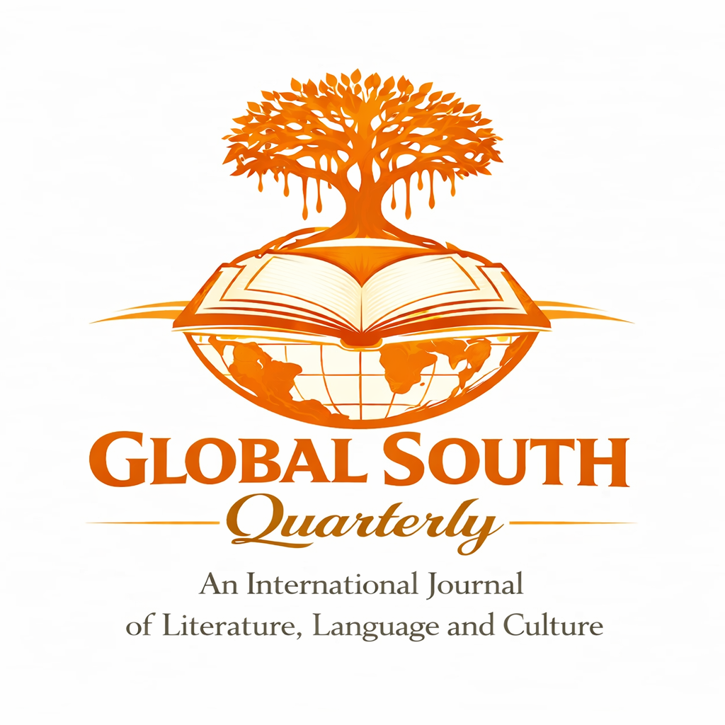Global South Quarterly
An International Journal of Literature, Language and Culture
Medium: Online/Print
Frequency: Quarterly
Language: English
Publisher: Independent Academic Journal, Under Dharwad Katte ®
Access Model: Open Access

Global South Quarterly: An International Journal of Literature, Language and Culture is a peer-reviewed academic journal committed to publishing high-quality, original research in humanities with a sustained focus on the Global South and its transnational connections. The journal offers an interdisciplinary platform for scholars working across literature, language, and cultural studies. The journal follows a rigorous peer-review process in accordance with international standards

Global South Quarterly publishes original, methodologically rigorous, and theoretically informed research in:
- Literary Studies
- Linguistics & Applied Linguistics
- Cultural Studies & Critical Theory
- Translation & Comparative Studies
- Film, Media, and Performance Studies
- Postcolonial and Global South Studies
- Interdisciplinary Humanities
- Indian Knowledge System
- Indian Poetics and Aesthetics
- Indian Folklore and Oral Literature
Types of Submissions
Research Papers: 4,000–8,000 words
Review Essays: 2,000–3,000 words
Book Reviews: 1000 – 1200 words
Creative-Critical Essays: 3,000–5,000 words
Translations: 2,000–5,000 words

Formatting Guidelines
- File format: .docx (MS Word)
- Font: Times New Roman, 12 pt
- Spacing: Double-spaced
- Citation style: MLA 9th Edition

Submission of Article
A soft copy of the manuscript (anonymous), along with a cover letter and copyright form, should be sent to The Editor, Global South Quarterly at globalsouthquarterly@gmail.com
Inaugural Issue: April 2026 (Forthcoming)
Last Date for Manuscript Submission: 20th March 2026
No APC required for this issue
The journal follows a strict plagiarism policy and accepts only those manuscripts whose similarity index is below 10%, as determined by standard plagiarism detection software.

Publication Ethics and Malpractice Statement
Global South Quarterly is committed to maintaining the highest ethical standards in scholarly publishing. We adhere to internationally recognized guidelines and best practices to ensure integrity, transparency, and excellence in academic research. Our editorial and review processes are designed to uphold rigorous peer review, prevent academic misconduct, and foster responsible scholarship. Authors and reviewers are expected to follow ethical principles in research, authorship, and publication, as outlined on our website. We actively discourage data fabrication, and conflicts of interest. By continuously refining our editorial policies and publication framework, Global South Quarterly strives to contribute to ethical and innovative scholarship in the field of literature, language and cultural studies.
Responsibilities of Authors
All materials submitted to Global South Quarterly, including research articles, review essays, book reviews, translations, and creative-critical contributions, must be the original work of the listed author(s) and appropriately attributed. The responsibility for ethical authorship rests primarily with the corresponding author, who initiates the submission and acts on behalf of all co-authors.
Authors are required to comply fully with the journal’s submission and formatting guidelines. Manuscripts must fall clearly within the journal’s stated aims and scope and adhere to the prescribed citation and style requirements. Research articles must demonstrate scholarly rigor through accurate citation, adequate referencing, and meaningful engagement with existing literature.
Authors must ensure that all data, interpretations, and arguments presented are accurate, transparent, and not intentionally misleading. Fabrication, falsification, plagiarism, or misrepresentation of sources constitutes unethical conduct and will result in rejection or retraction of the manuscript.
The corresponding author is responsible for confirming that:
- All listed authors have made a genuine scholarly contribution and have approved the final version of the manuscript;
- The submission is not under consideration elsewhere and has not been previously published;
- Any use of AI-assisted tools, copyrighted material, or third-party content is properly disclosed;
- Ethical standards in research and publication are strictly upheld.
- Authors have the responsibility to ensure that their research is genuinely original and not plagiarised or very similar to work that is either already published or known to them as being in the process of publication.
- All co-authors are aware of the submission and have consented to publication.
- Proper acknowledgement is given to all contributors, including those providing intellectual, technical, or material support.
- Relevant funding sources, institutional affiliations, or supporting entities are credited.
- Authors are responsible for disclosing any competing interests at the point of an article’s submission, which will then be listed in the final published article. Failure to disclose competing interests may result in the journal being unable to publish the article, even if it passes peer review.
- A signed Conflict of Interest (COI) statement must be submitted before publication. Or it must be stated in manuscript.
- Authors must endeavour to make all necessary revisions to their manuscripts following peer review feedback. If authors are not able to make the necessary changes to their article, this may result in the article’s rejection.
- If their article is accepted for publication, authors should be amenable to copyediting queries and further suggested changes prior to the article’s publication.

By submitting a manuscript to Global South Quarterly, authors agree to uphold the principles of academic integrity, originality, and responsible scholarship.

Changes in Authorship
Requests for authorship changes (additions, removals, or reordering) must be submitted to the Chief Editor before the publication of the article and:
- Authors cannot be added or removed at any point prior to publication unless an adequate reason is given to editors for why this is necessary.
- Unjustified addition or removal of authors will be considered a case of malpractice and will not be tolerated by the journal.
- Require unanimous consent from all listed authors for any changes in authorship.
1.3. Unethical Authorship Practices
The journal strongly condemns:
- Ghost Authorship – Omitting individuals who have made substantial contributions.
- Guest Authorship – Listing individuals despite minimal or no contribution.
- Gift Authorship – Adding individuals as a courtesy without meaningful contribution
Defamation and Promotional Content
- Authors must ensure that their submissions do not contain defamatory content or serve as promotional material. Work submitted to Global South Quarterly should contribute to critical discourse without misrepresentation or bias.
Global South Quarterly employs a single-Blind Peer Review process for fair and unbiased evaluations.
6.1. Review Process Overview
- Initial Assessment – The editorial team assesses scope and relevance.
- Reviewer Selection – One expert evaluates anonymously.
- Reassessment by the Reviewers – After the modification or corrections are done by the authors according to the comments and suggestions by the reviewer, the modified/revised article will be considered for publication.

Board
Founder & Editor-in-Chief: Prof. Basavaraj P. Donur
Head of the Dept., Central University of Karnataka
basavarajdonur@cuk.ac.in
Executive Editors:
Subhamoy Kar, Faculty, CUK
Karsubhamoy2@gmail.com
Mob. 9883958245
Dr. Vijayalakshmi Danaraddi
Associate Professor
Govt. First Grade Degree College, Dharwad

Editorial Board
Dr. Elisabetta Marino
Professor
University of Rome, Tor Vergata

Dr. Khagendra Acharya
Professor
Kathmandu University, Nepal

Dr. Alok Kumar
Professor
Deen Dayal Upadhyaya Gorakhpur University, UP

Dr. Amitkumar, Professor
The English and Foreign Languages University, Hyderabad

Dr. N. H. Kallur
Professor of English, Karnatak University, Dharwad
nhkallur@kud.ac.in

Advisory Board
Prof. Shivanand Kelaginamani
Vice-Chancellor
Adikavi Shri Maharshi Valmiki University, Raichur
M V Alagwadi
Former Vice-Chancellor
Central University of Karnataka, Kalaburgi

Prof. Manukonda Rabindranath
Centre for Media Studies
Jawaharlal Nehru University, New Delhi

Prof. Sandhya Tiwari
Dean, School of Humanities
Central University of Kashmir

Owner Name:
Journal Address:
Articles published in this journal will be licensed under a Creative Commons Attribution 4.0 International License (CC BY 4.0).


